# CS 255 System Design Document

## UML Diagrams

### UML Use Case Diagram

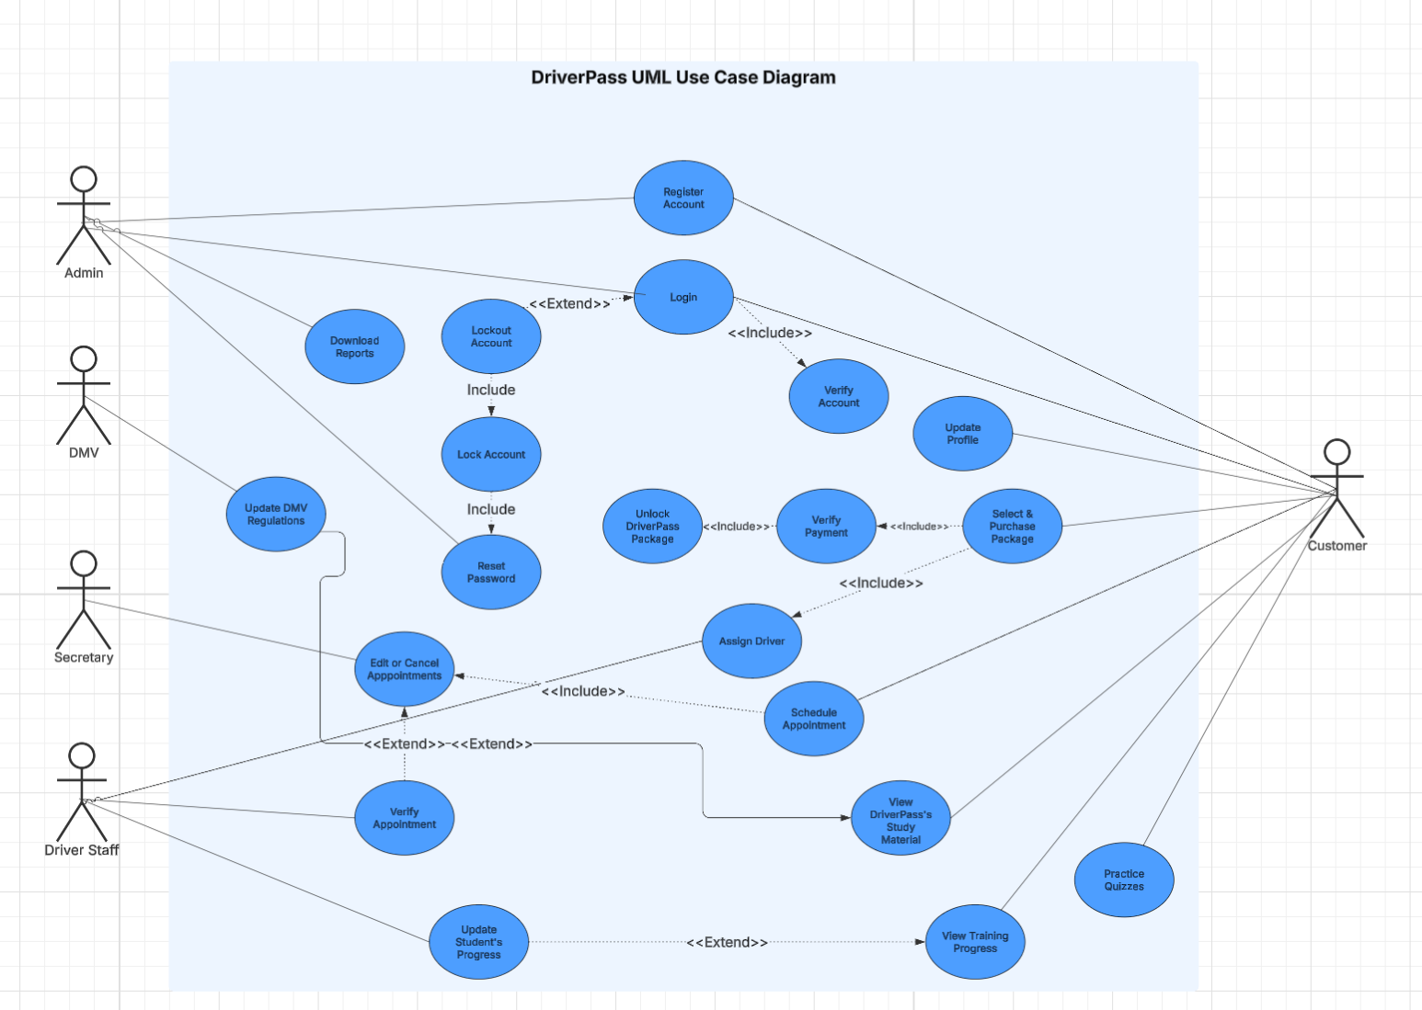

### UML Activity Diagrams

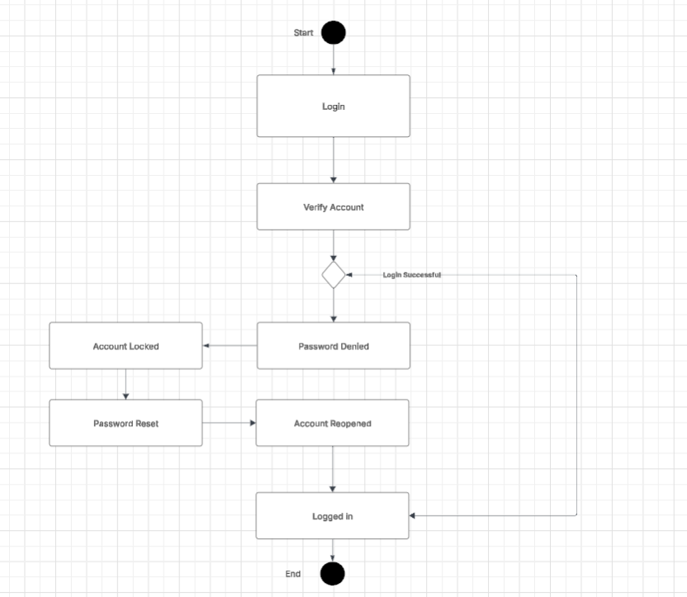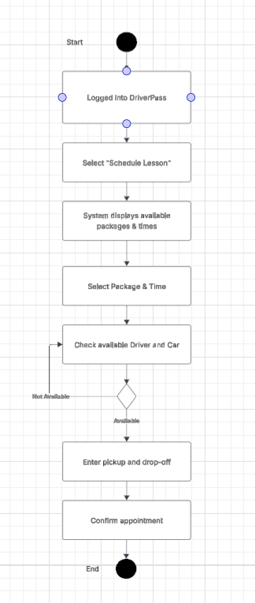

### UML Sequence Diagram

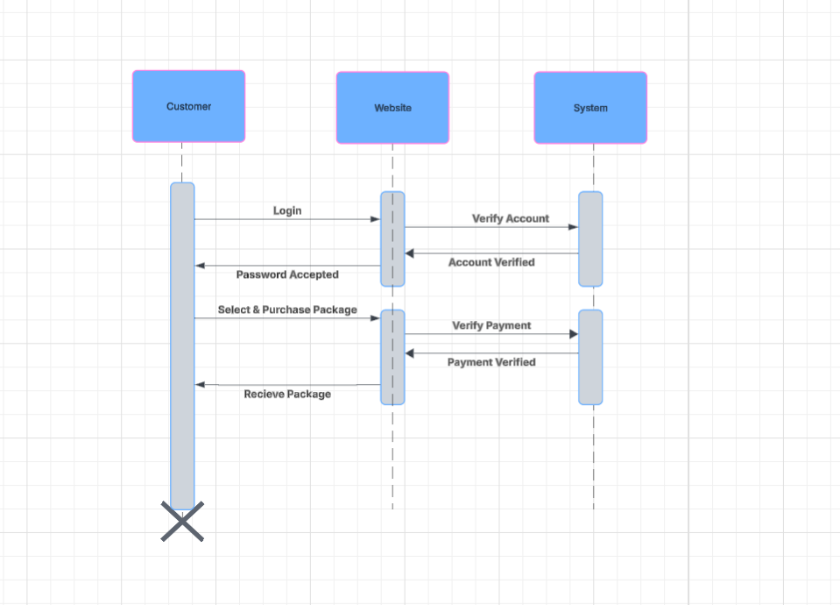

### UML Class Diagram

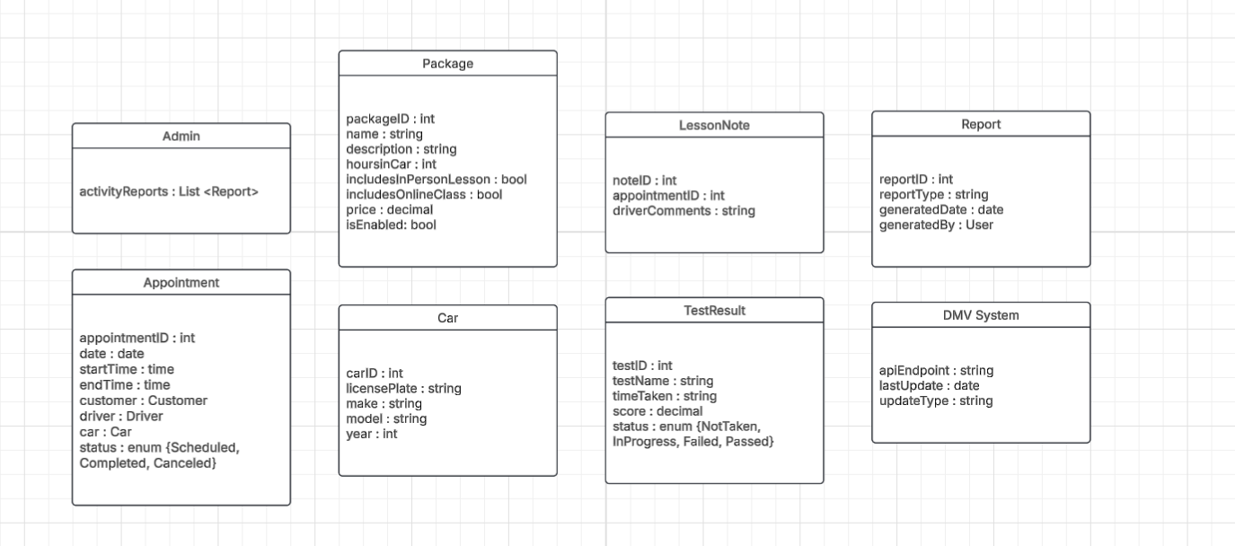

## Technical Requirements

* **Hardware Technical Requirements**  
  + Client Devices
    - Desktop and laptops
    - Mobile device compatibility
  + Networking Equipment
    - Reliable internet connection
  + Peripherals for Staff
    - Printers for reports and schedules
    - Backup storage for data loss
* **Software Technical Requirements**
  + System software
    - Modern operating systems on client device***s***
  + Application Software
    - Supporting web browsers
    - Secure Payment
    - DriverPass web application with role-based access control
  + Utility Software
    - Cloud backup services
    - Security
* **Tools Technical Requirements**
  + Development Tools
    - Integrated Development Environment like Visual Studio Code
  + Web frameworks
  + Database Management Tools
* Infrastructure Technical Requirements
  + Cloud hosting
    - Scalable cloud platform for hosting web application and database
    - Ensure high availability
  + Security Infrastructure
    - Encrypted data transmission
    - Role-based access permissions for different user types
    - Secure password storage and reset function
  + Integration
    - API connection to DMV systems for automated updates